**Props**

* Props are read only and can’t be changed
* Props can be used both in class and functional components

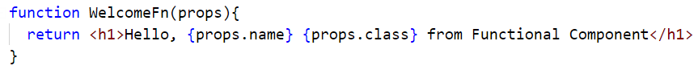

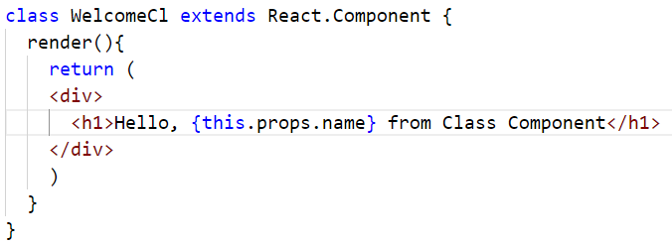

* ‘n’ number of props can be send as arguments whereas props <= n can be used. Meaning is NOT necessary that all the arguments must be rendered.
* Props can be send as arguments at the time of instantiating components

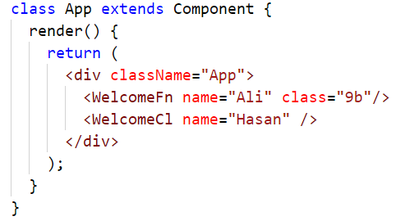

* All React components must act like pure functions with respect to their props

**State**

* State is similar to props but it is private and fully controlled by its component.

